**EXP 7**) Create a simple cloud software application for Students Attendance System using any Cloud Service Provider to demonstrate SaaS include the necessary fields such as name of the students, course, present , Absent, course attendance, OD request, grade, attendance percentage, etc.

**PROCEDURE:**

**STEP 1:** GOTO ZOHO.COM

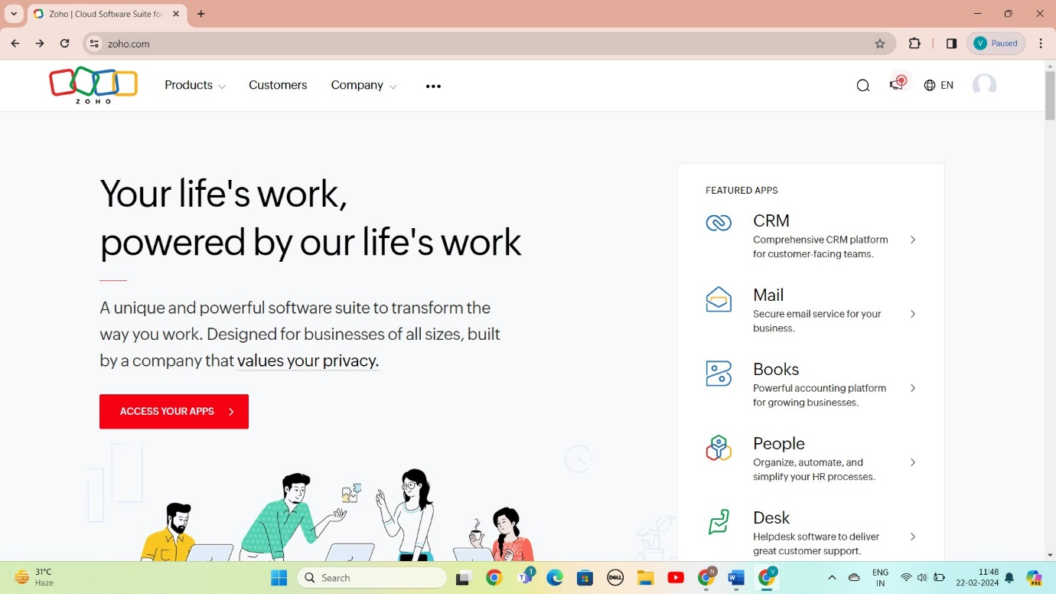

STEP 2: LOGIN TO THE ZOHO.COM

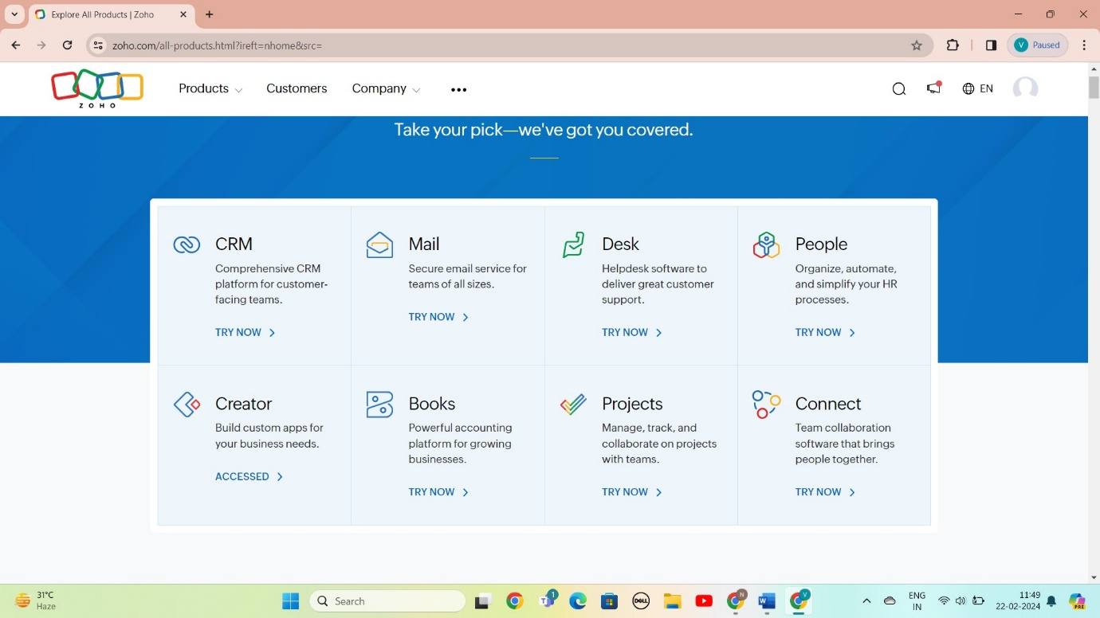

STEP 3: SELECT A CREATE FROM SCRATCH

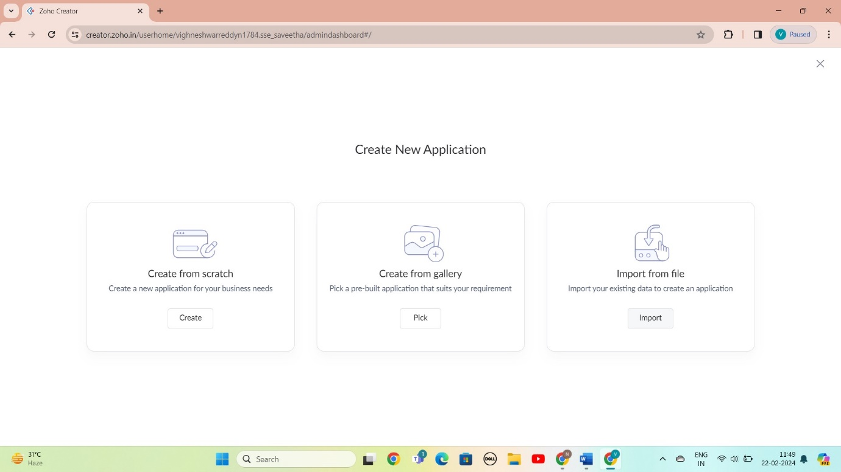

STEP 4: SELECT APPLICATION NAME AS Students Attendance System

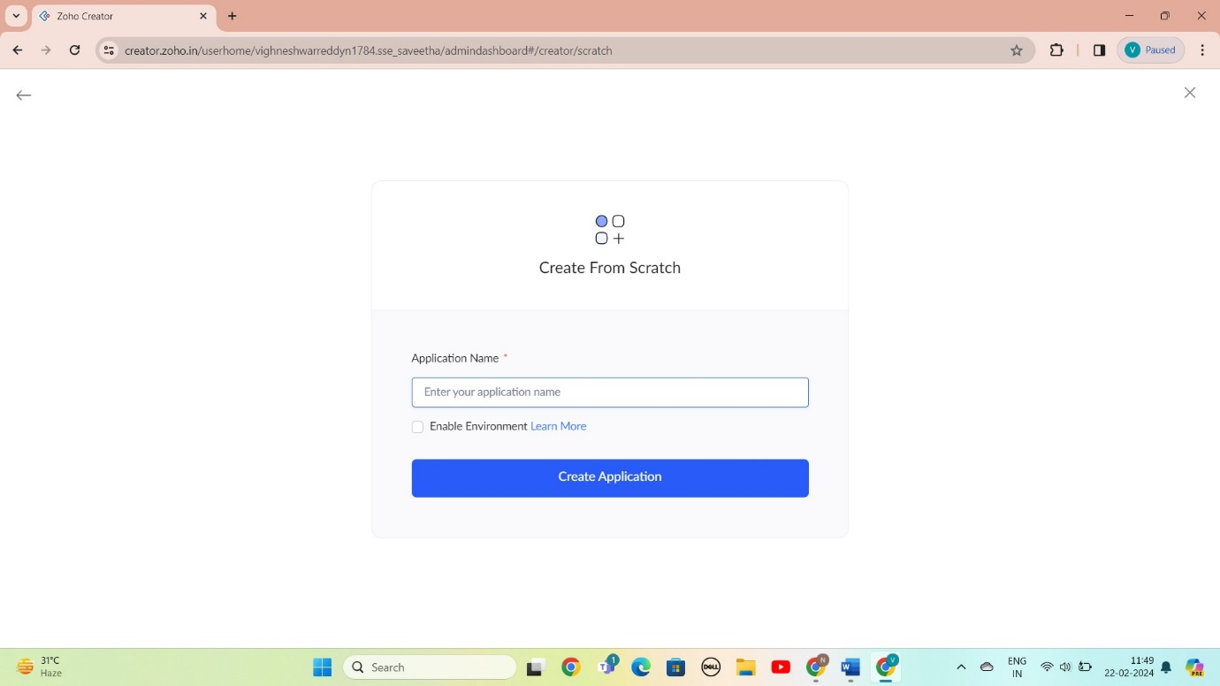

STEP 5: CREATED NEW FORM

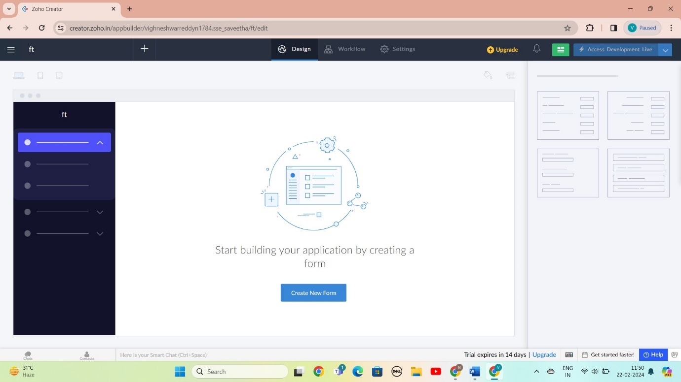

STEP 6: SELECT BASIC FILED FROM GIVEN BELOW AND DEVELOP APPLICATION

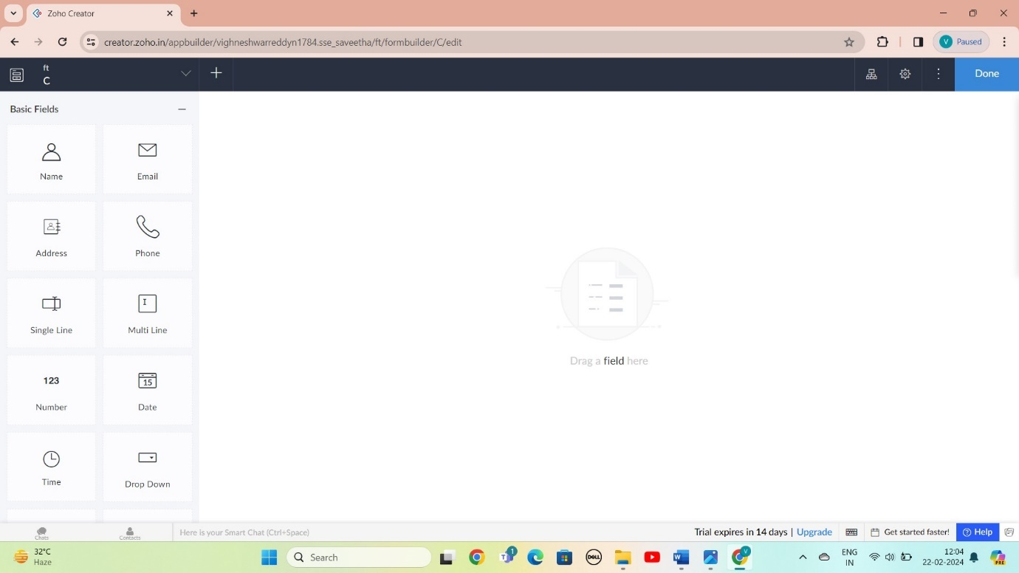

STEP 7: THE SOFTWARE AS BEEN CREATE LOGIN TO ATTEDENC PROTOL

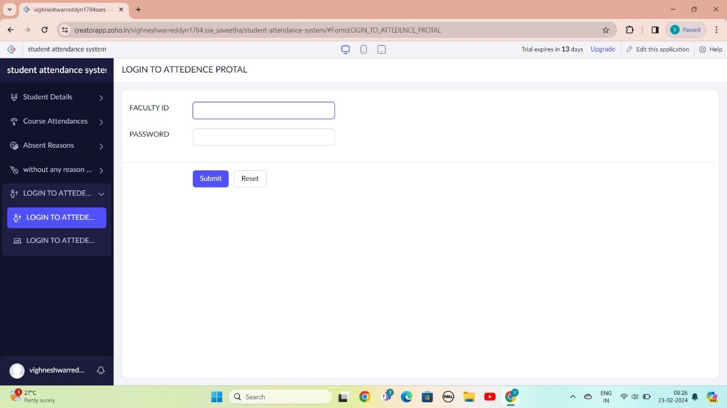

STEP 8: THE SOFTWARE AS BEEN CREATE STUDENT DETAILS

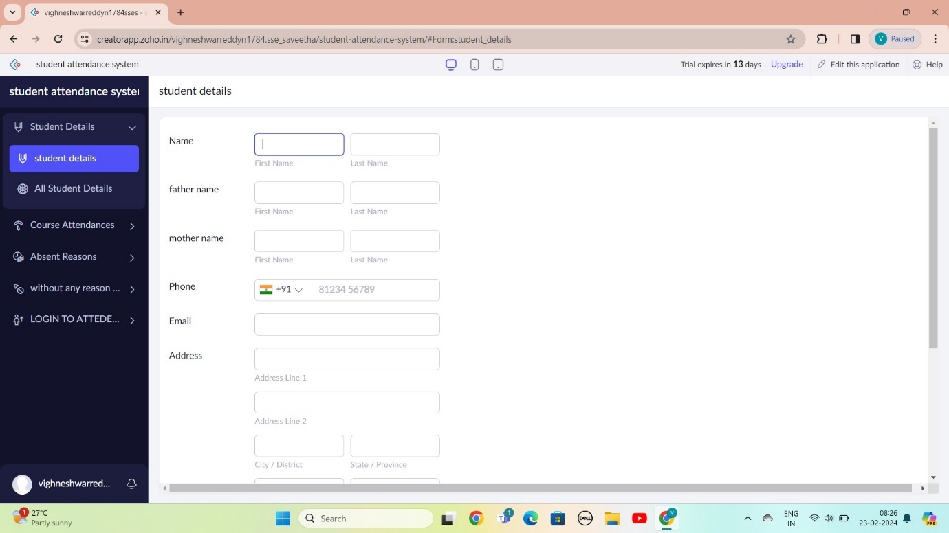

STEP 9: THE SOFTWARE AS BEEN CREATE COURSE ATTEDENCE

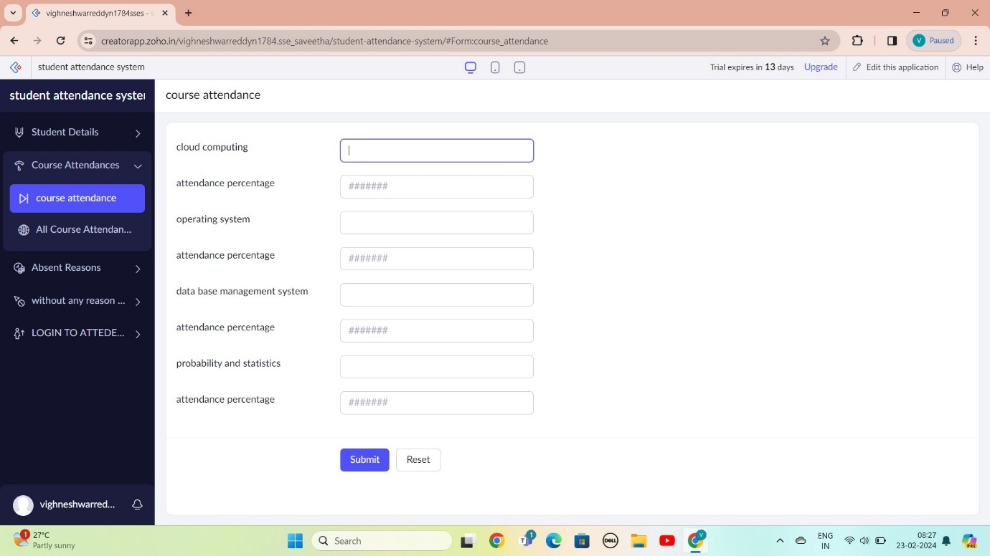

STEP 10: THE SOFTWARE AS BEEN CREATE ABSENT REASON

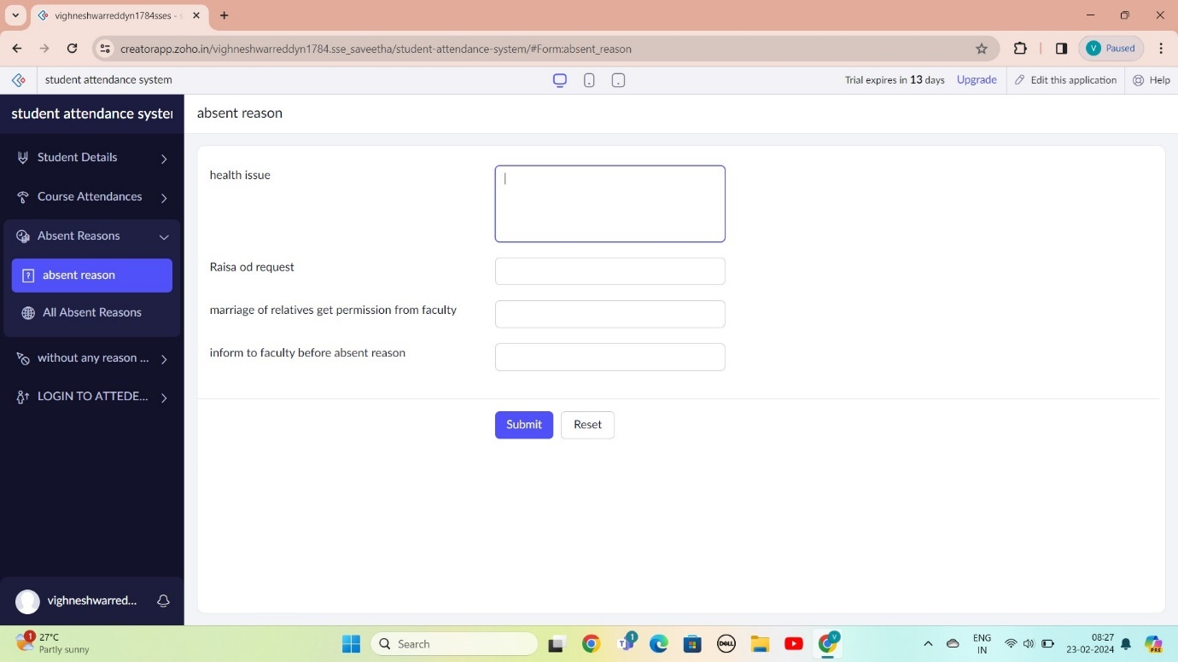

STEP 11: THE SOFTWARE AS BEEN CREATE WITHOUT ANY REASON ABSENT

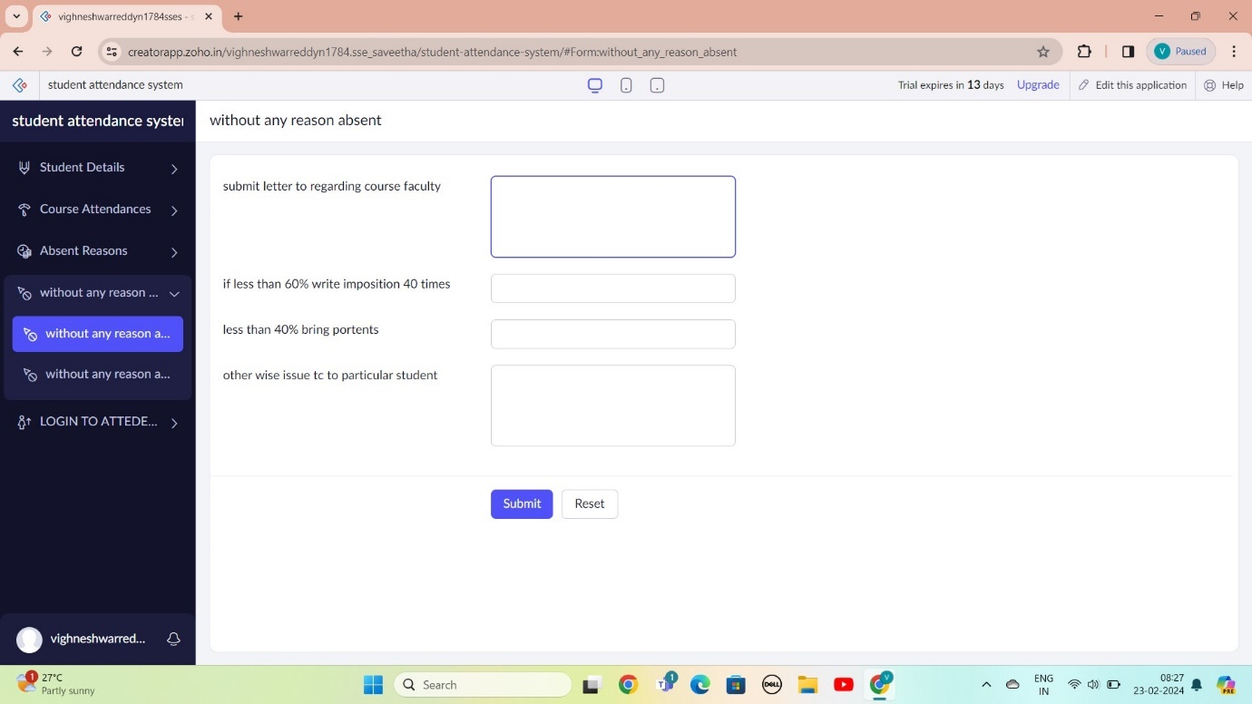

STEP 12: THE SOFTWARE AS BEEN CREATE

